P.Keerthi

192011340

CSA0734- Computer Networks for Server Management Experiment no:14

AIM:

To design the functionalities and exploration of tcp using packet tracer.

REQUIREMENTS:

1. End device - They are the devices through which we can pass message from one device to another and they are interconnected.

2.Switch/Hub - Interface Between two devices.

3.Cable - Used to connect two devices.

4.server

Procedure:

STEP 1: Click on end devices, select generic Pc’s drag and drop it on the window. Click on SWITCH drag and drop it on the window. and also connect the server to the switch.

STEP 2: Select the straight through cable and connect all end device to switch. Assign the IP address for all end devices. (Double click the end device Select → desktop → IP configuration static)

STEP 3: Now set the IP address to Host A (192.168.1.1) in static mode. Similarly set IP address for Host B (192.168.1.2) and Host C (192.168.1.3)

STEP 4: To view the IP address, give ipconfig command in command prompt. Using ping command, we can establish communication between two host devices.

STEP 5: Now display the packet transmission in simulation mode.

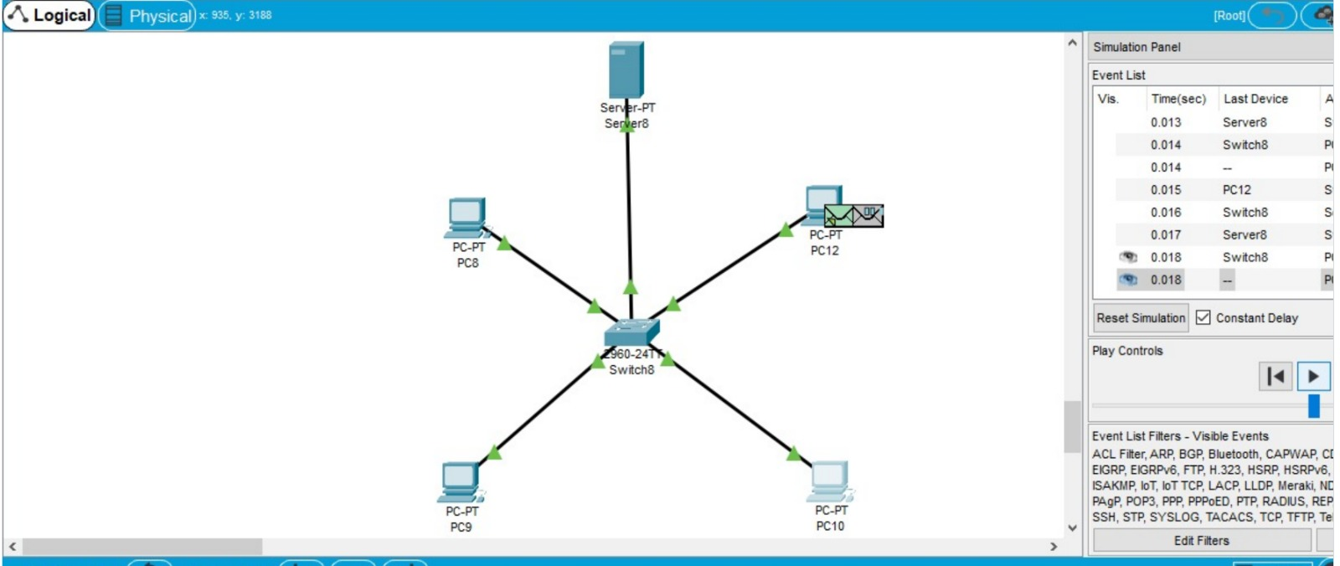

RESULT:

The design of functionalities and exploration of tcp is successfully done.